**Problem Statement:**

You work for XYZ Corporation and based on the expansion requirements of your corporation you have been asked to create and set up a distinct Amazon VPC for the production and development team.You are expected to perform the following tasks for the respective VPCs.

**Production Network:**

1. Design and build a 4-tier architecture.

2. Create 5 subnets out of which 4 should be private named app1, app2, dbcache and db and one should be public, named web.

3. Launch instances in all subnets and name them as per the subnet that they have been launched in.

4. Allow dbcache instance and app1 subnet to send internet requests.

5. Manage security groups and NACL’s

Go to the AWS console and create VPC by providing the below details and click on the **create VPC**

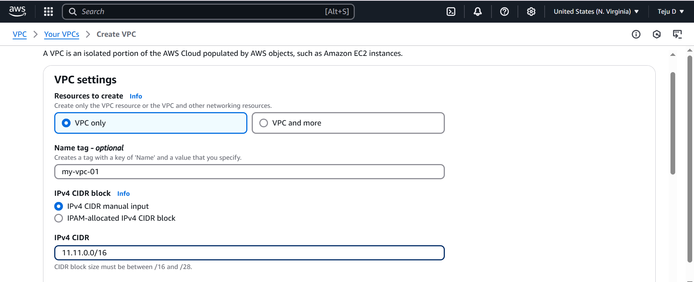

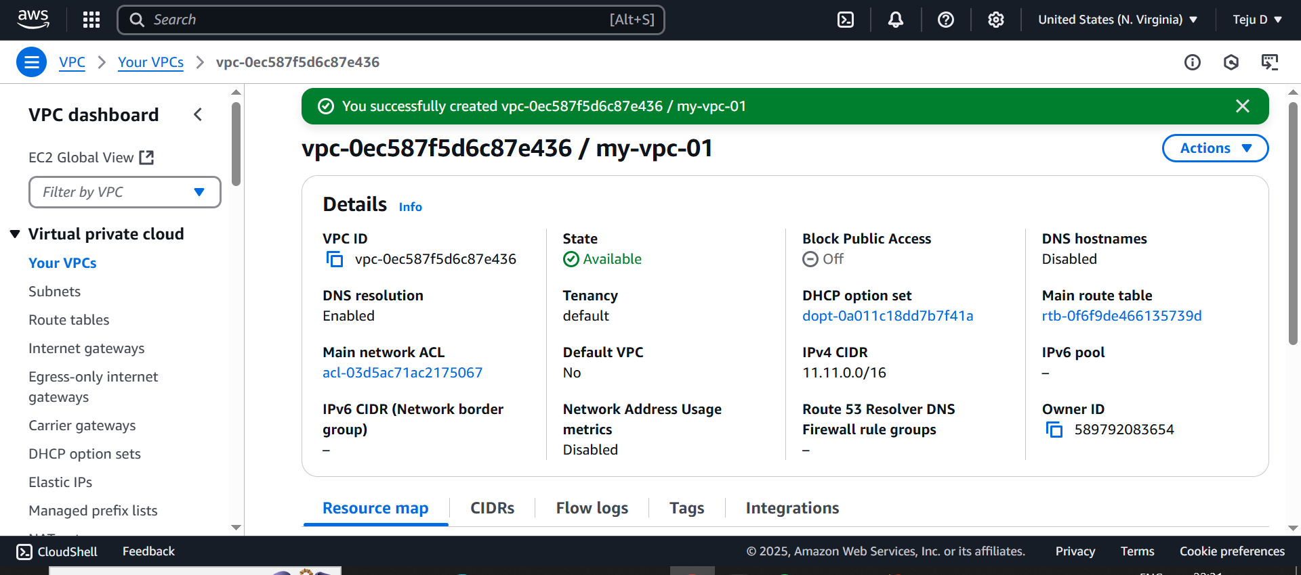

Update the RouteTable name which is already created

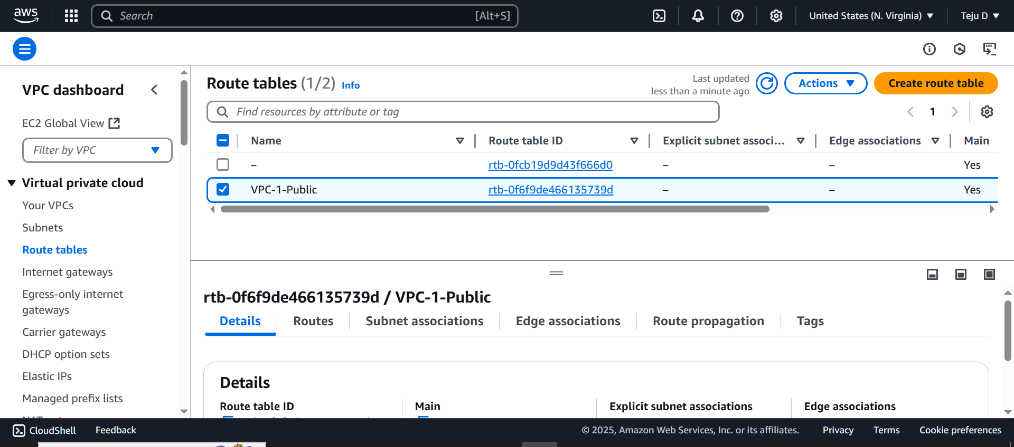

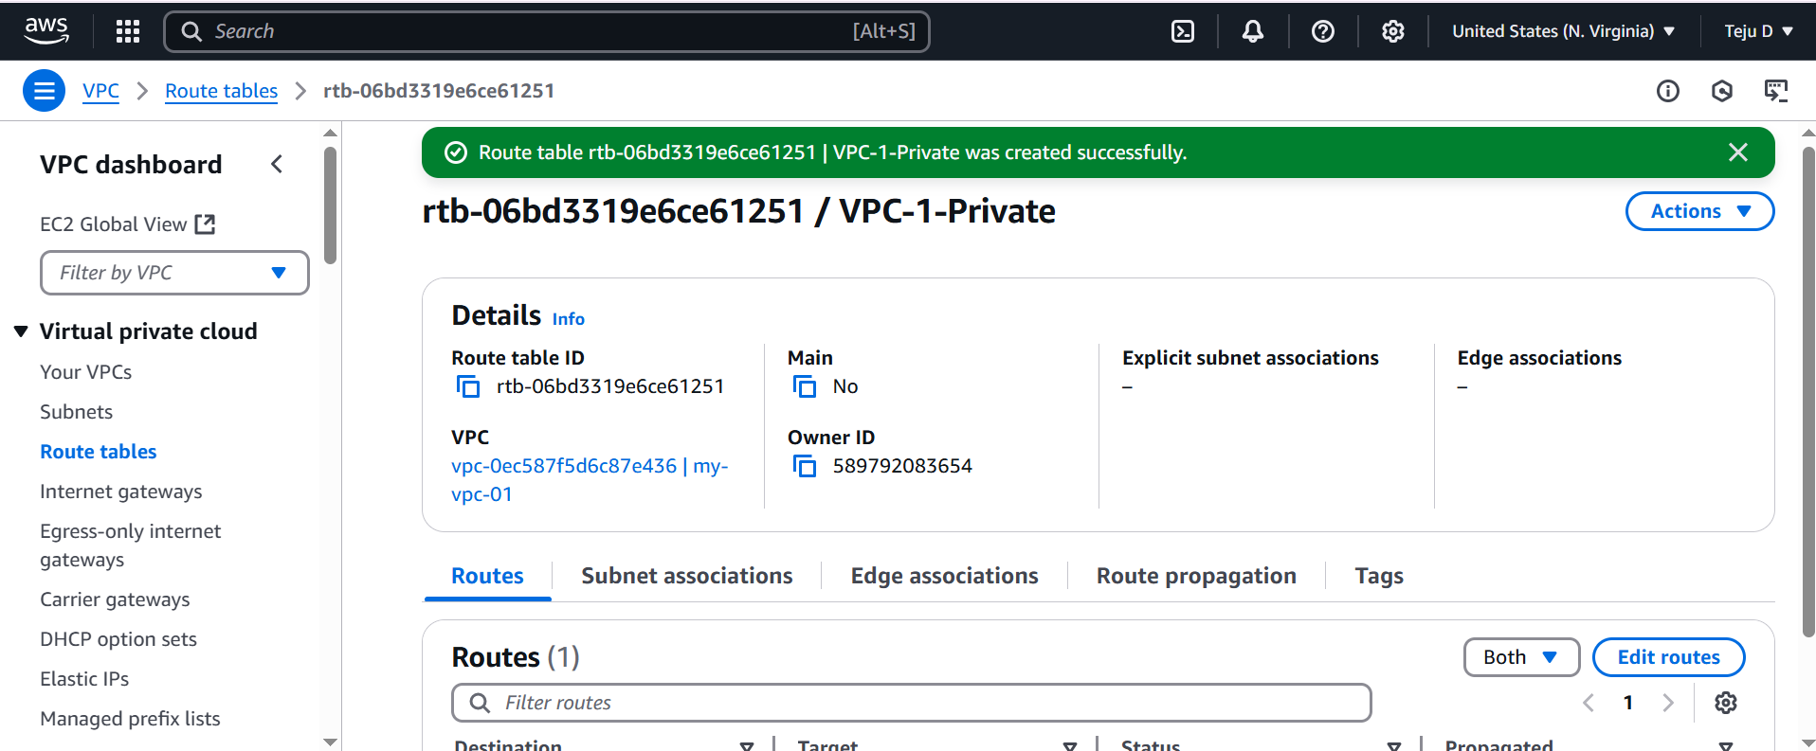

Create a 3rd routetable

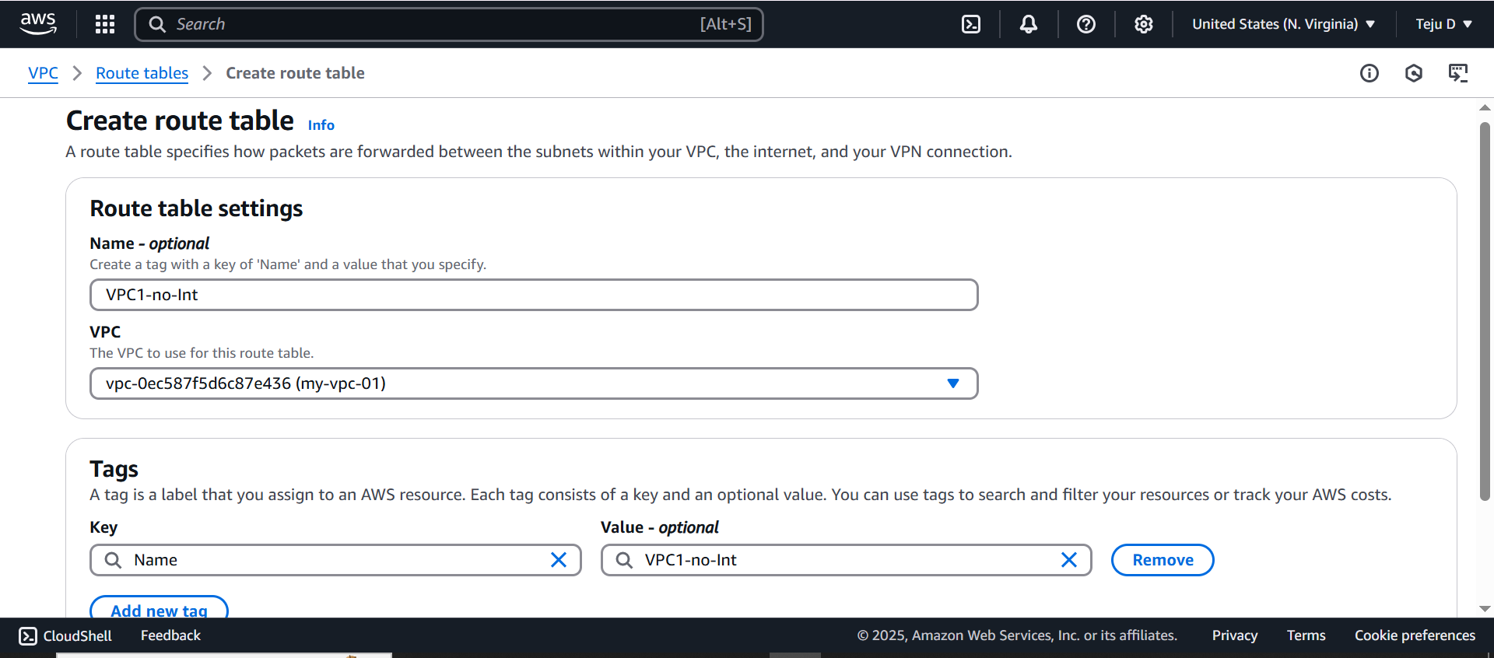

Create a new routetable for Private

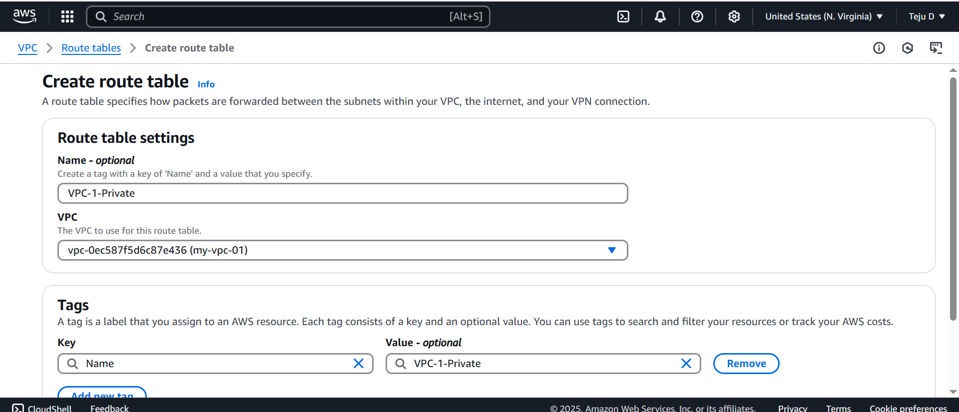

Create a 5 Subnets

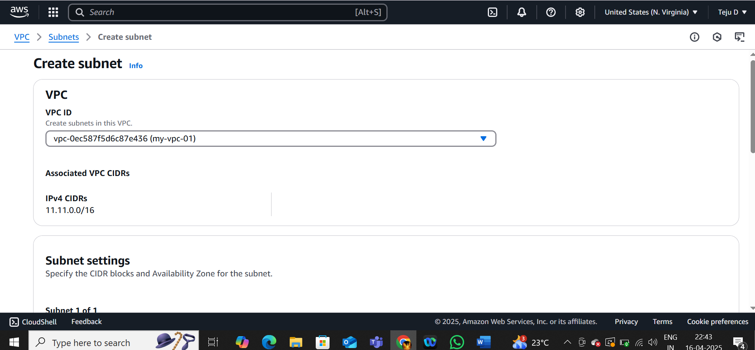

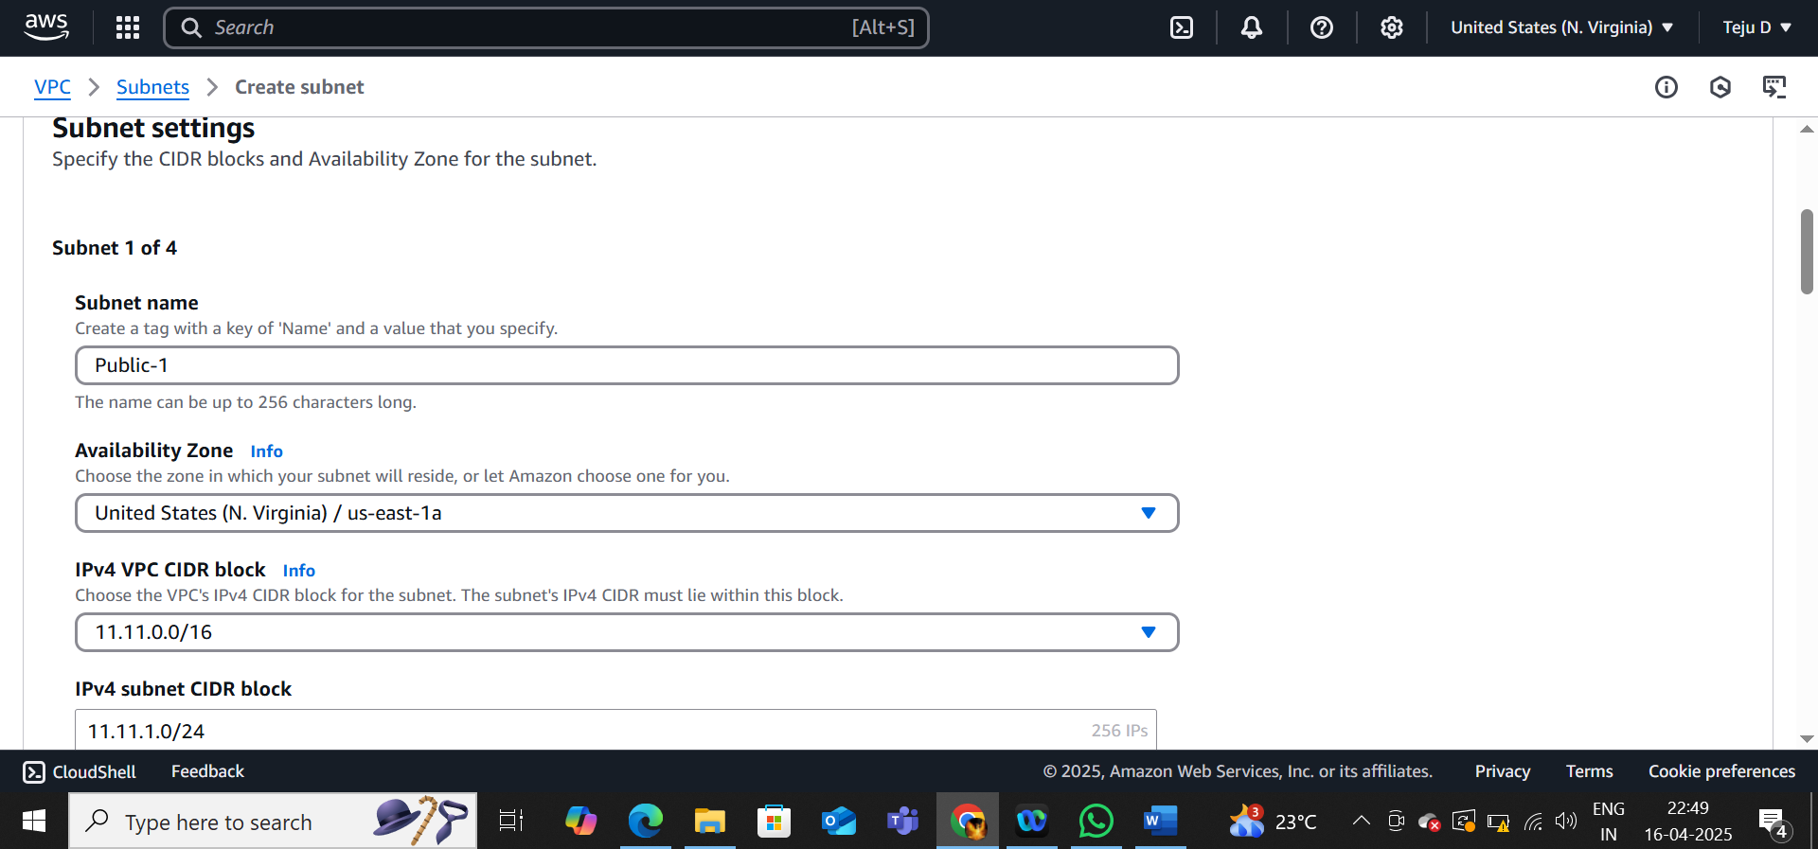

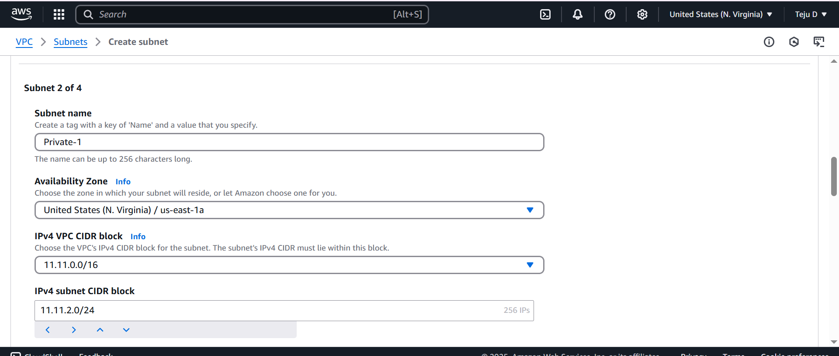

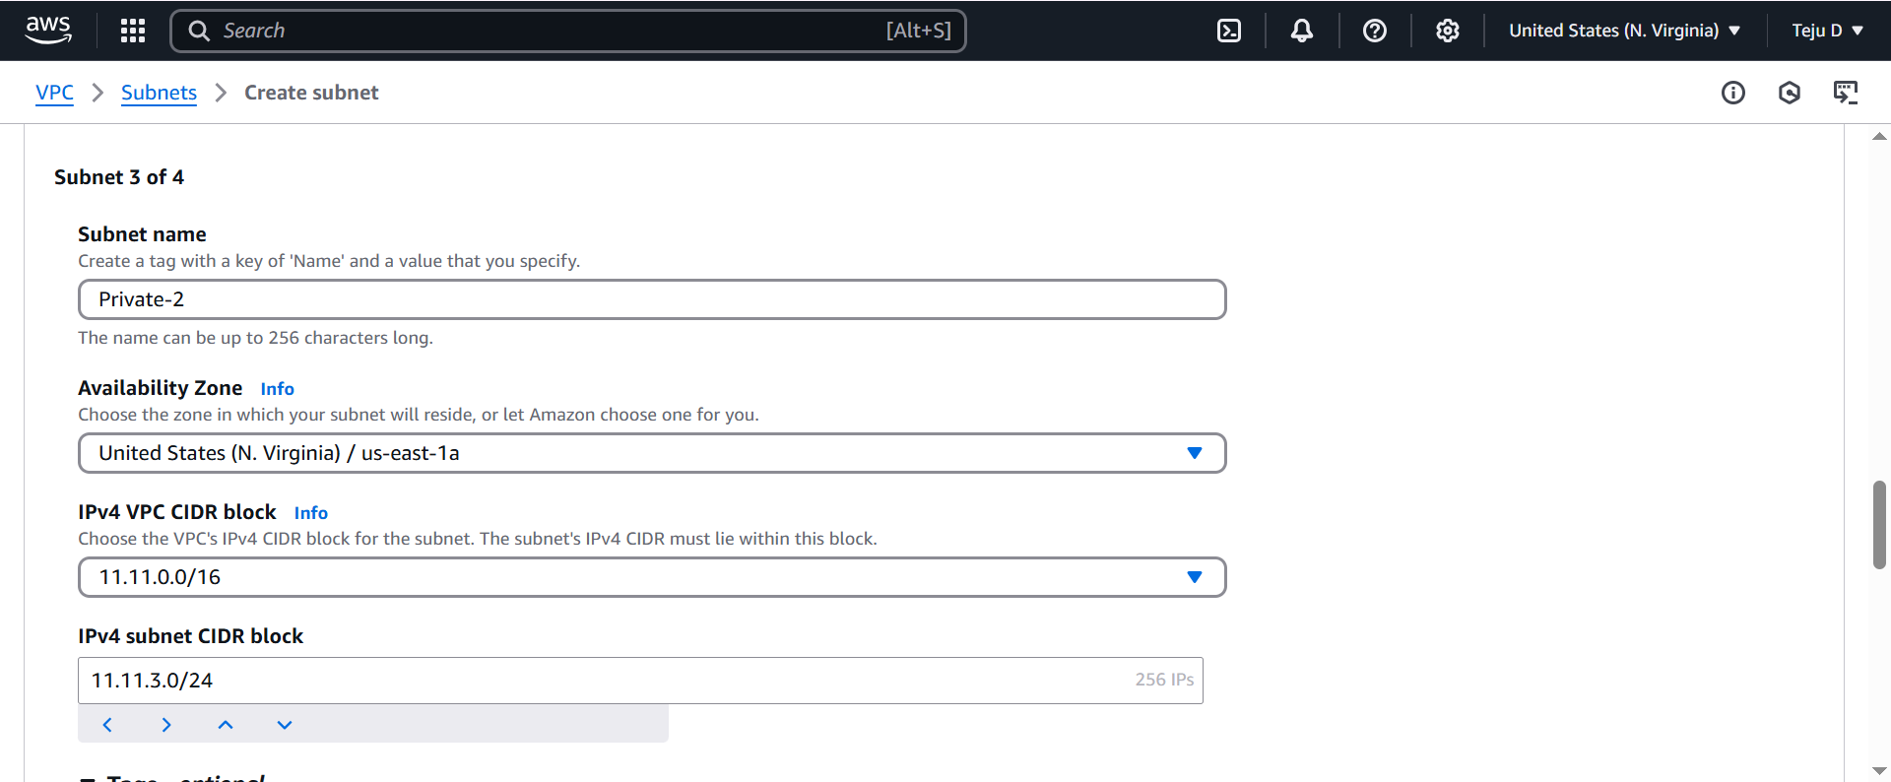

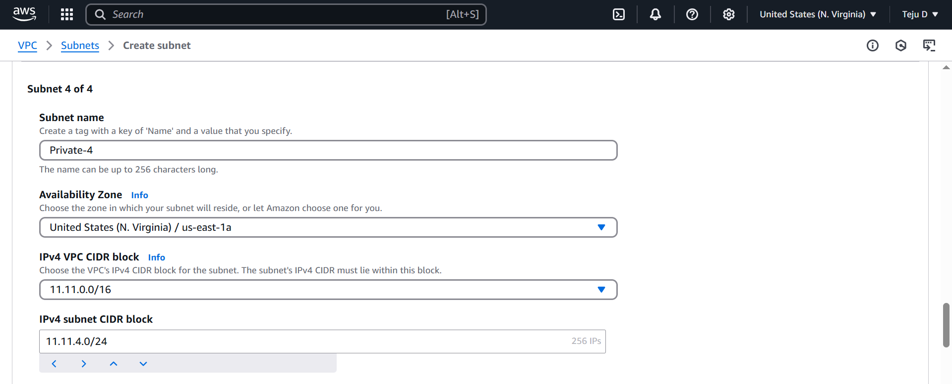

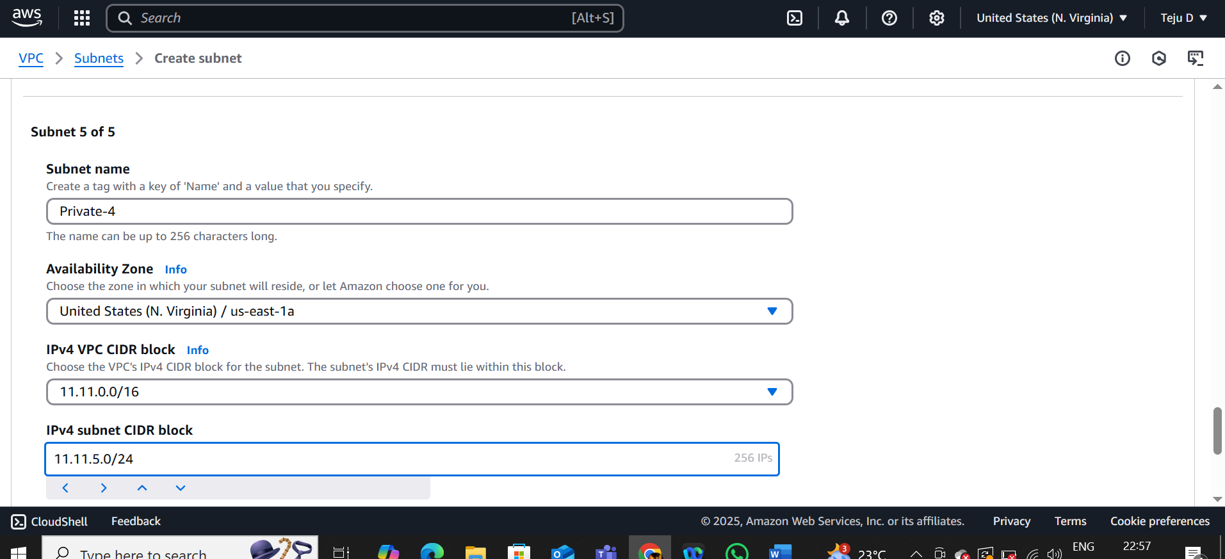

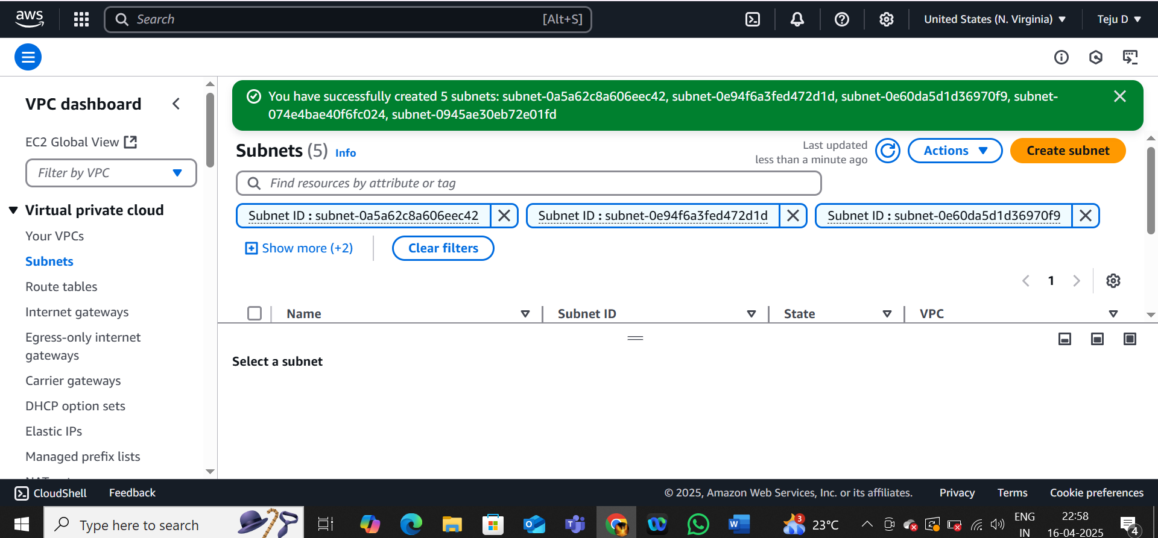

Create an Internet Gateway and attach it to VPC

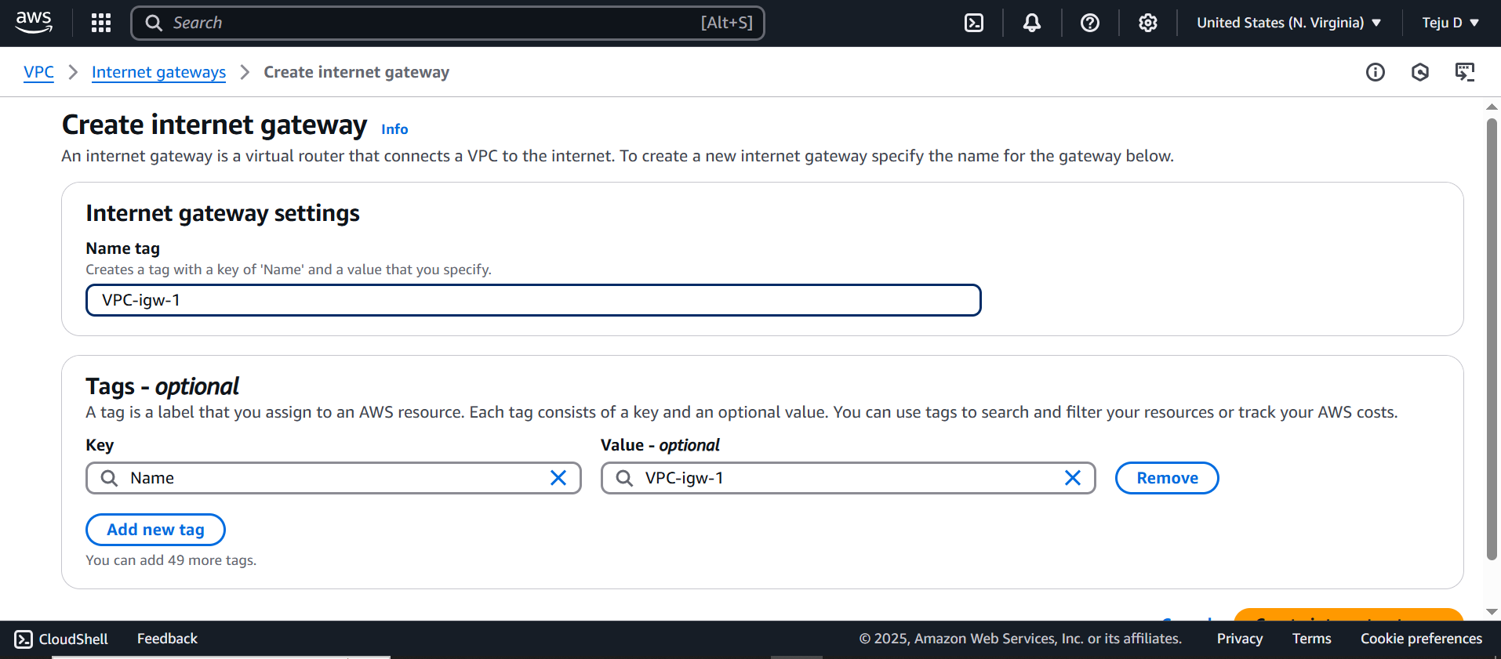

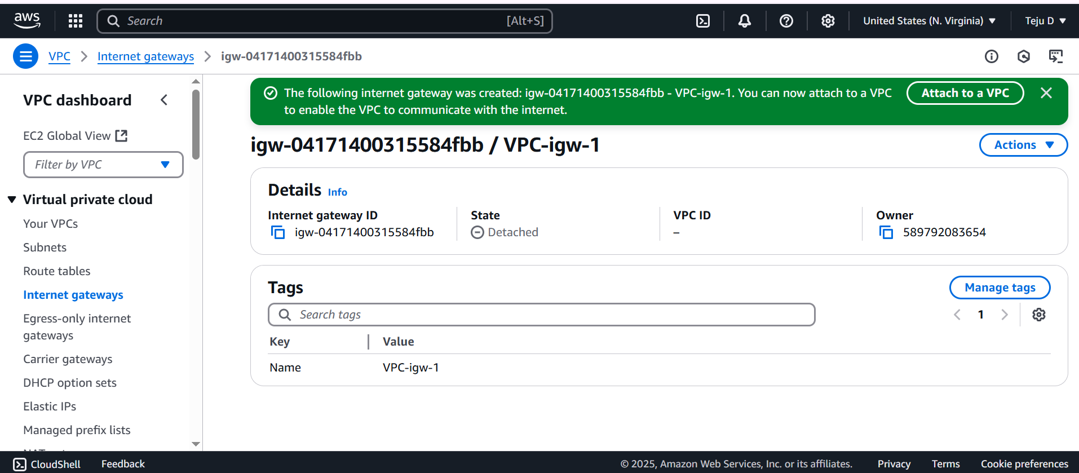

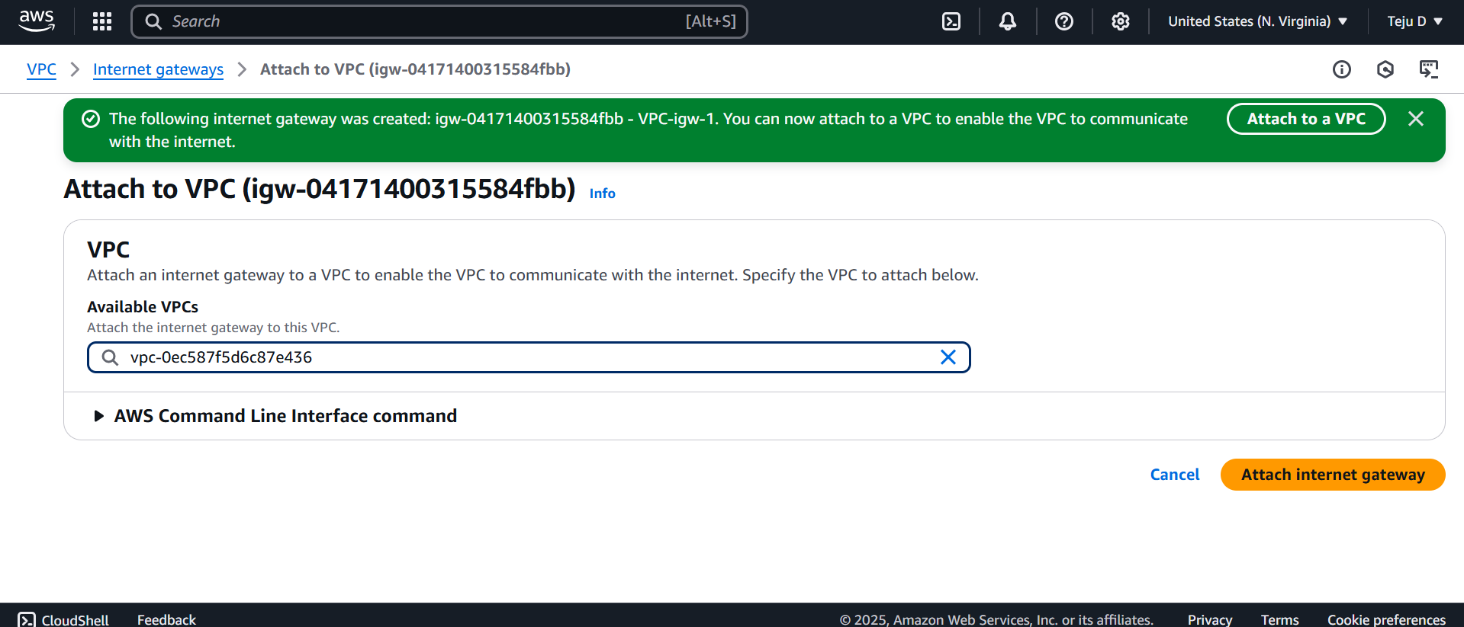

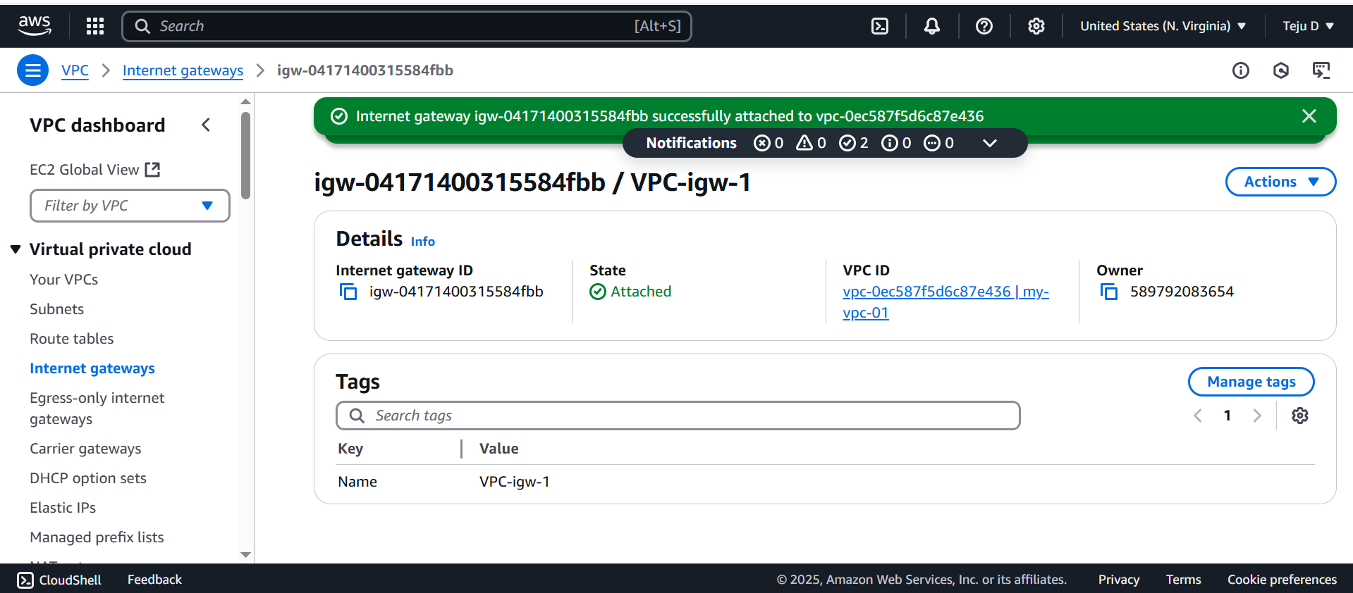

Create NAT Gateway providing below information. Click on allocate Ealastic IP to get one

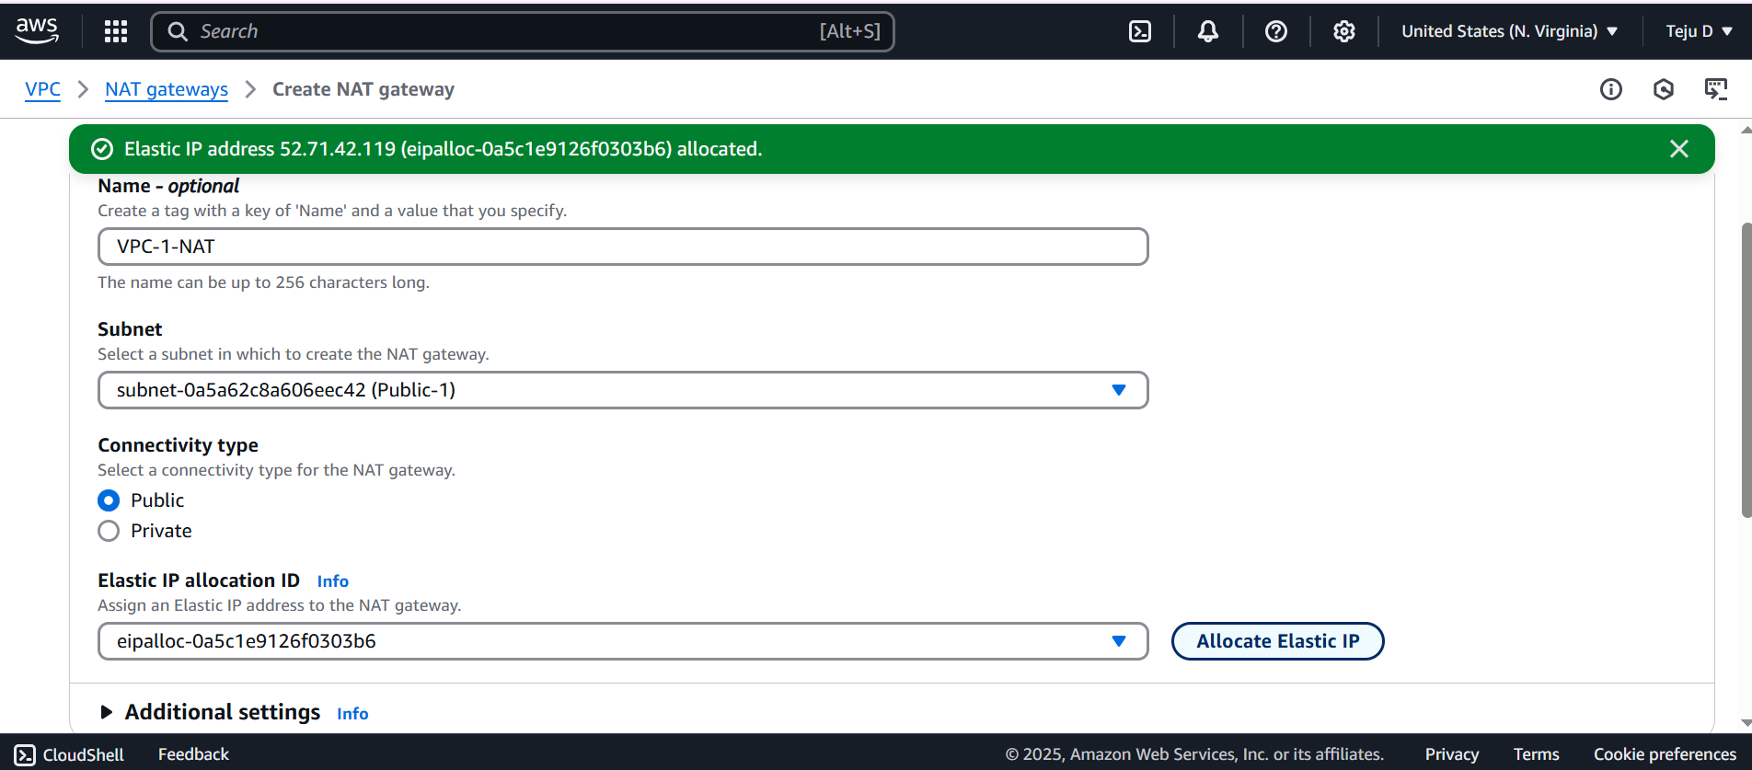

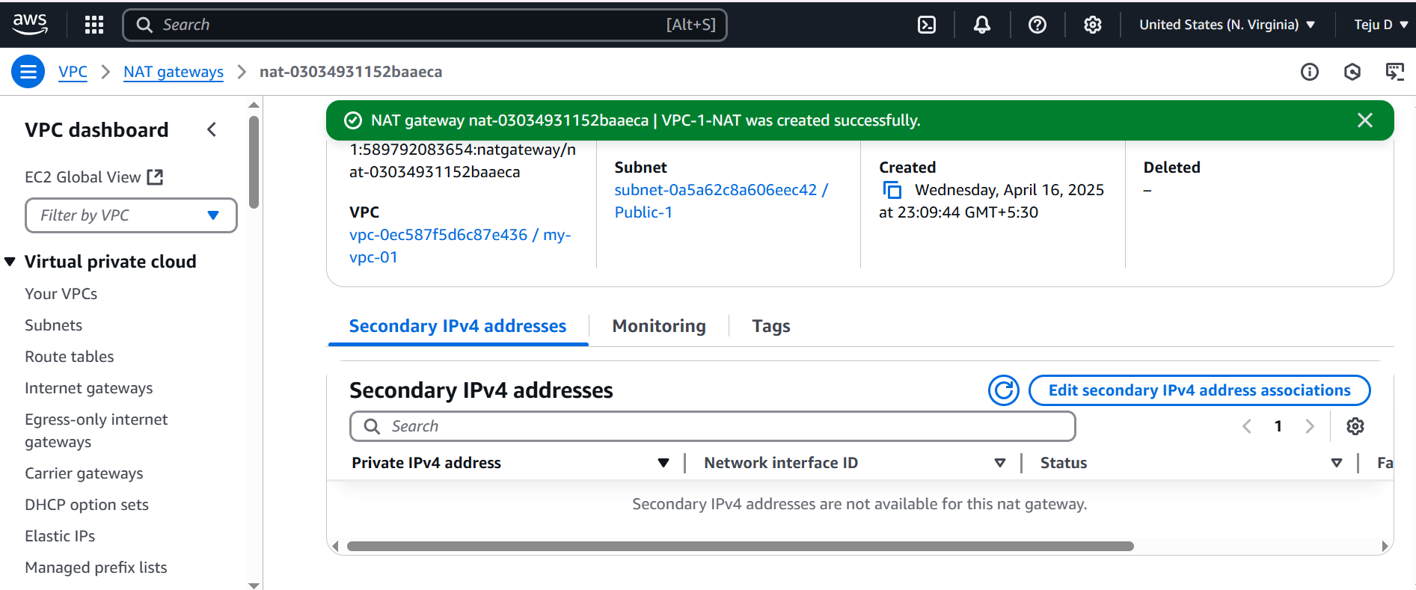

Go to routetable – VPC-1-Public routetable – edit route – add route – add the provide the below details then **save changes**.

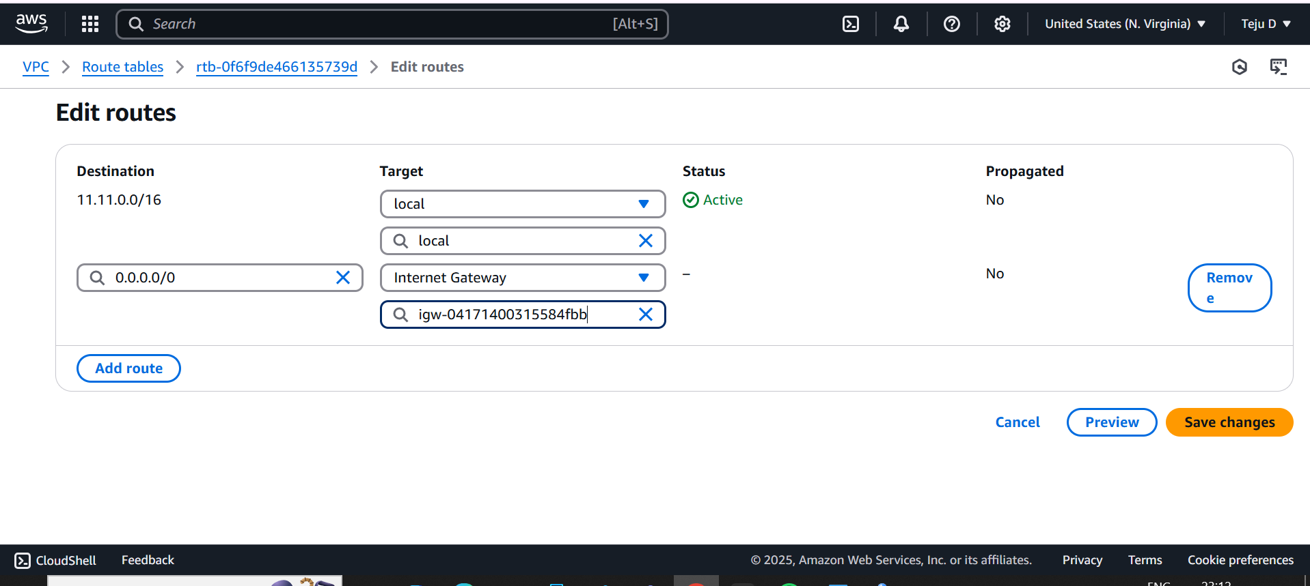

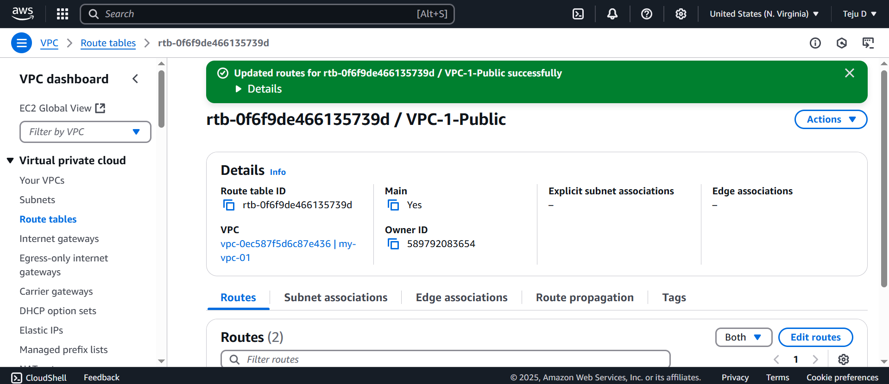

Go to subnet association – edit subnet association – choose the public subnet – **click on** save association

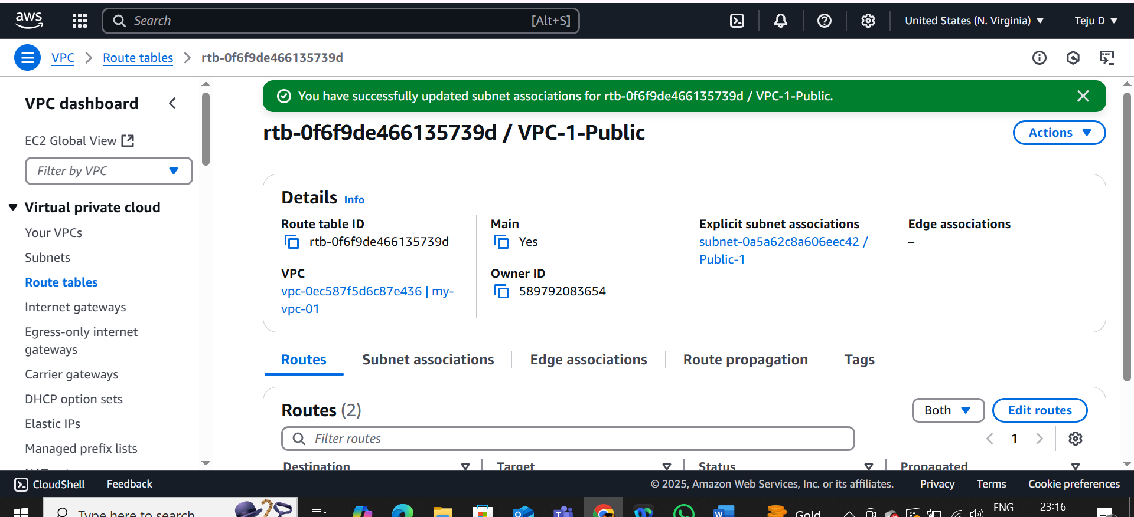

Go to routetable – VPC-1-Private routetable – edit route – add route – add the provide the below details then **save changes**.

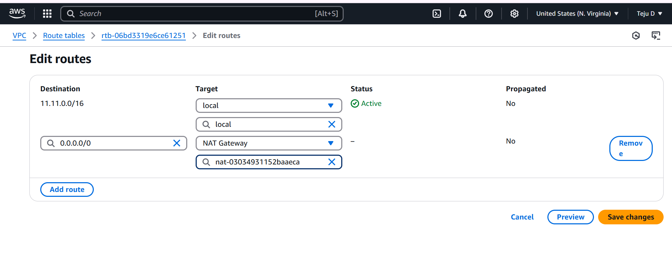

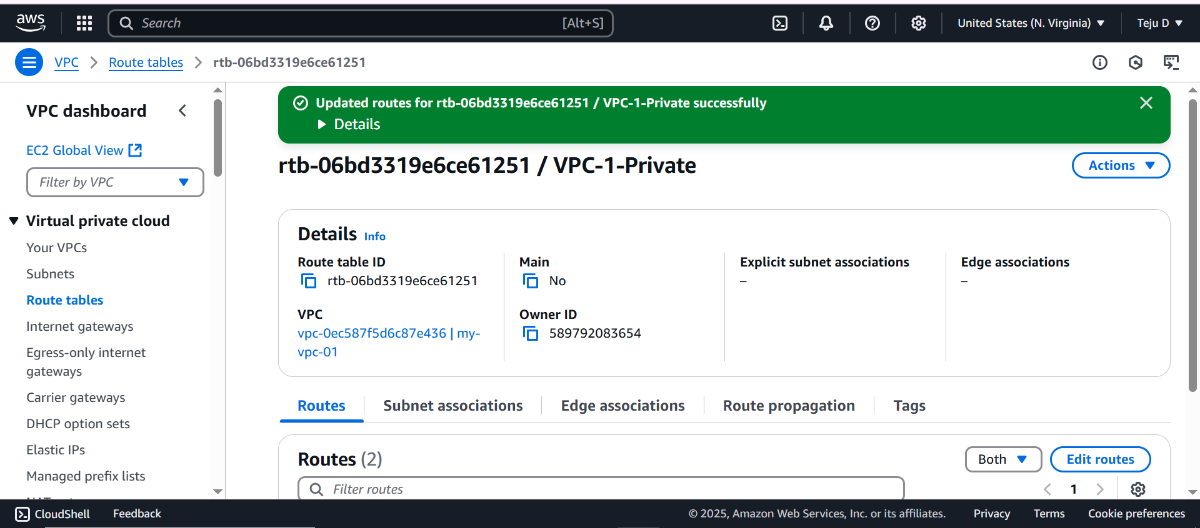

Go to subnet association – edit subnet association – choose the private-1 and Private-2 subnet – **click on** save association

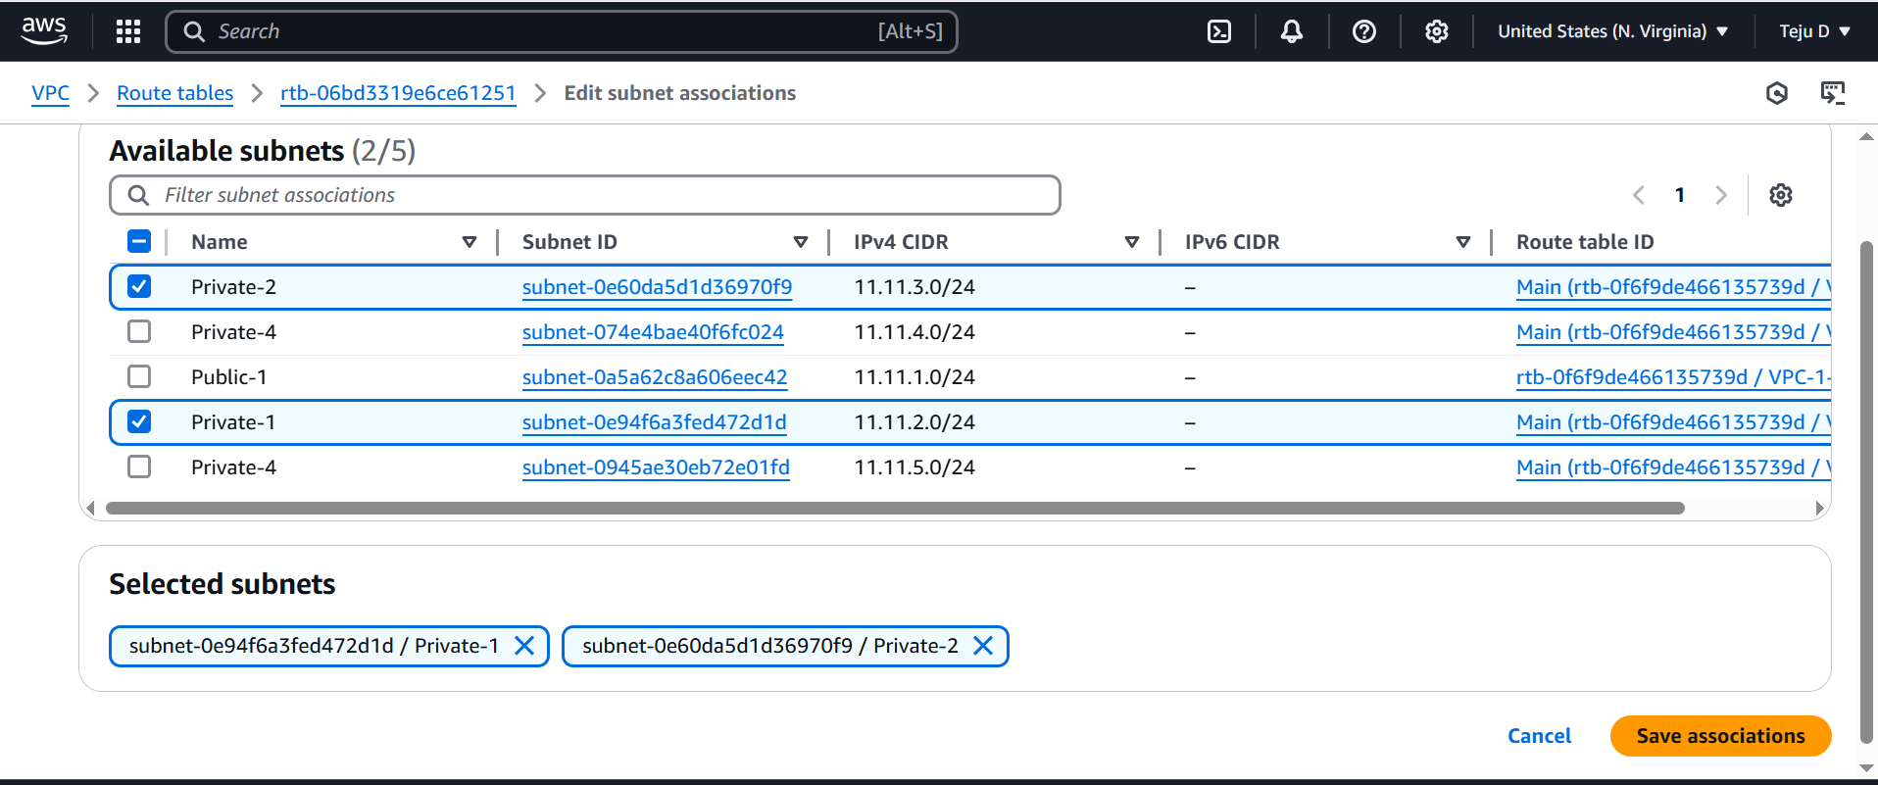

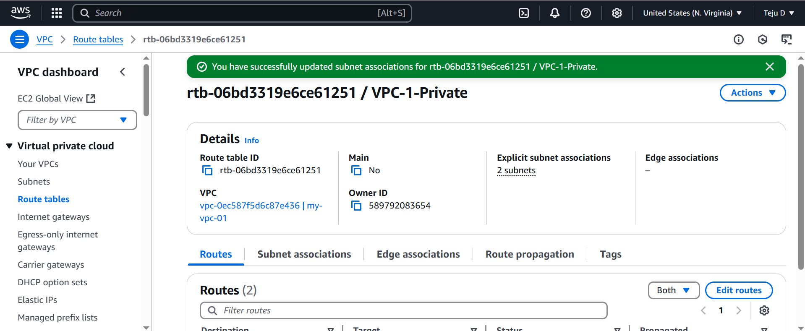

Go to routetable – VPC-1-no-int- Go to subnet association – edit subnet association – choose the private-3 subnet – **click on** save association

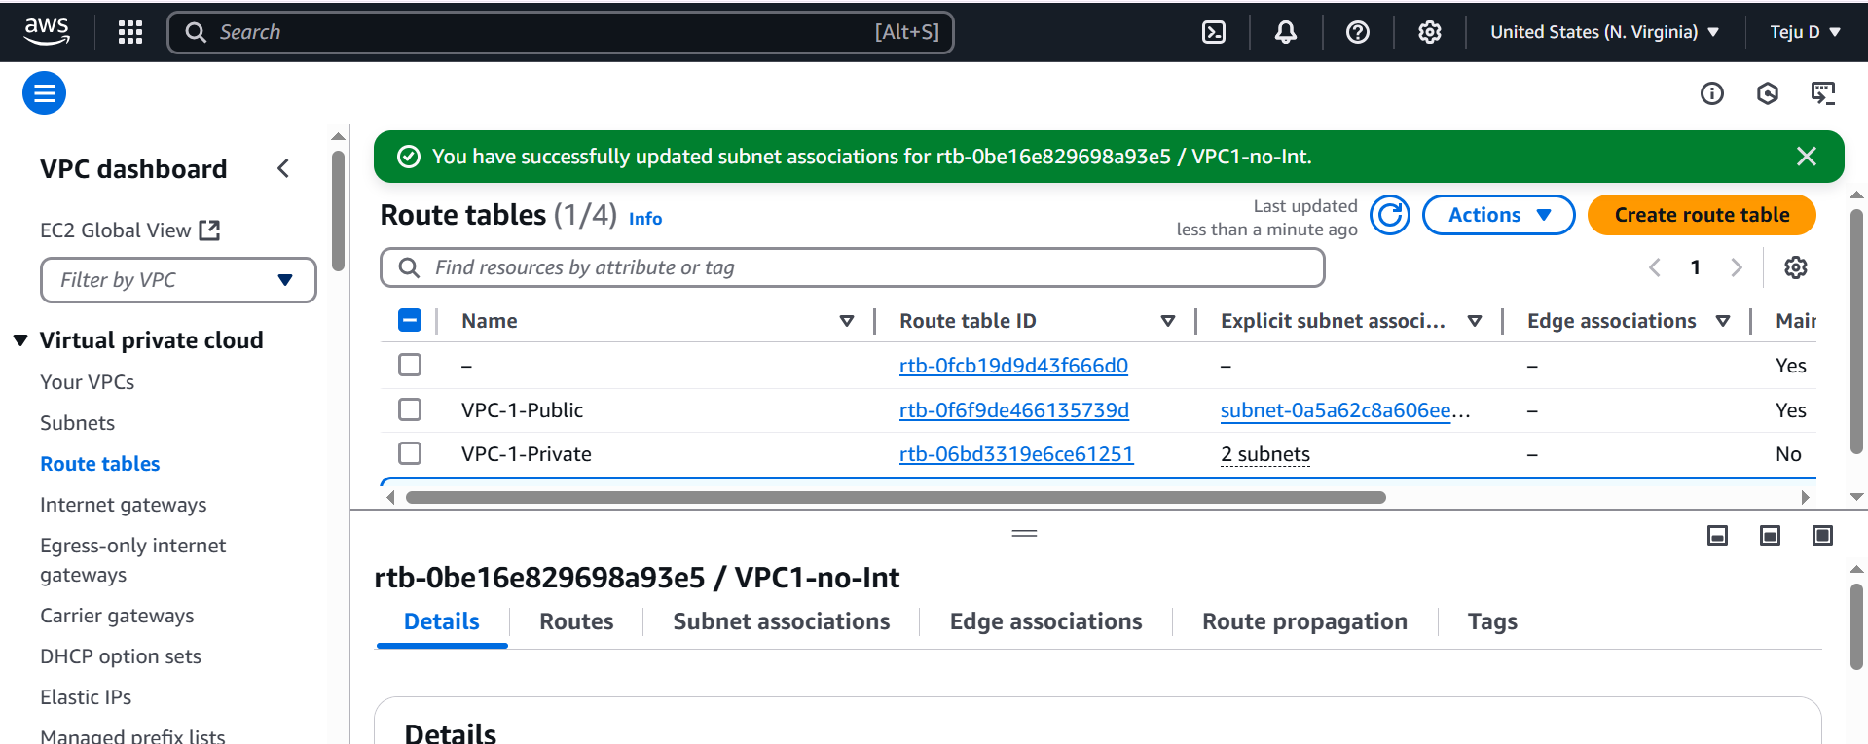

Launch an instance for Public-1 subnet and choose free tier AMI and instance type

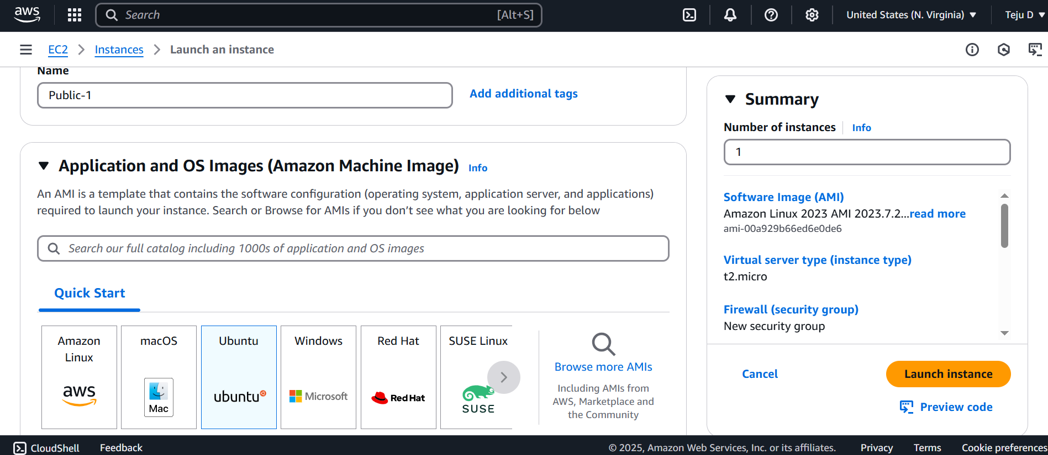

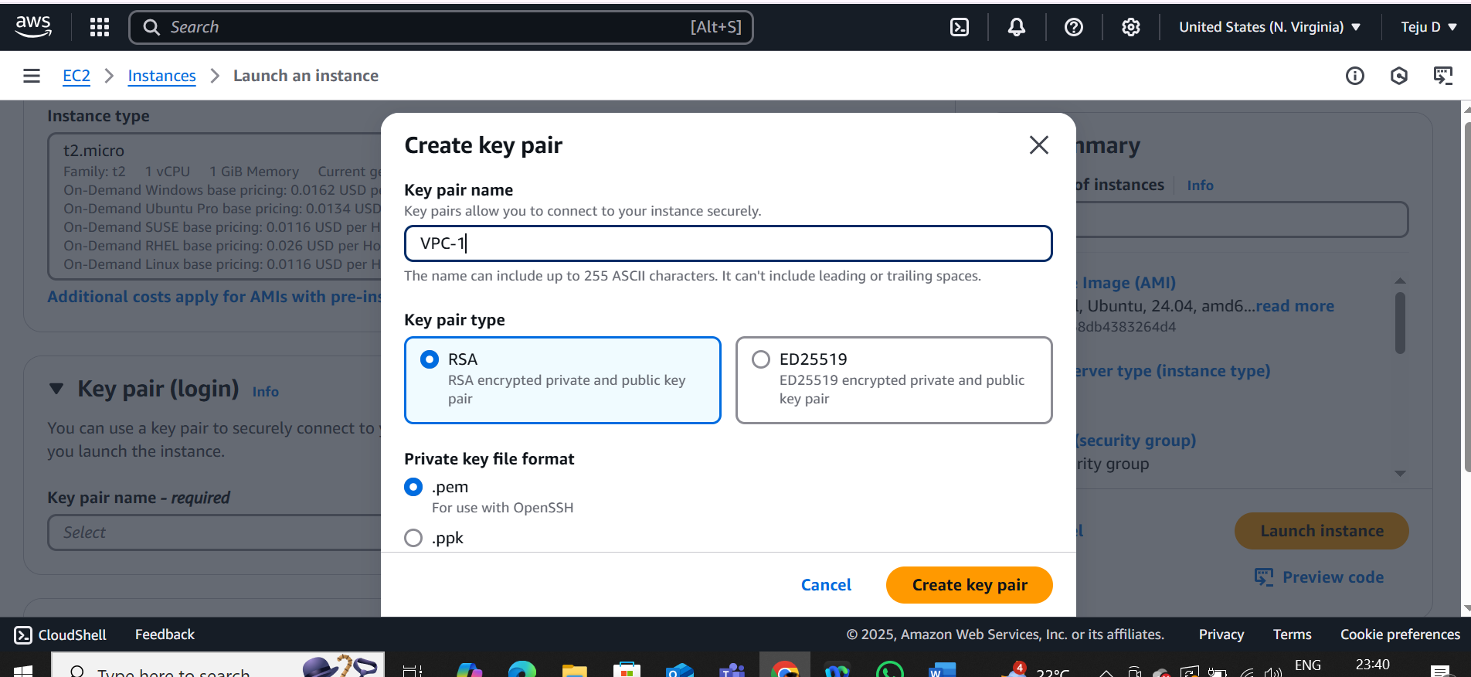

Edit network settings

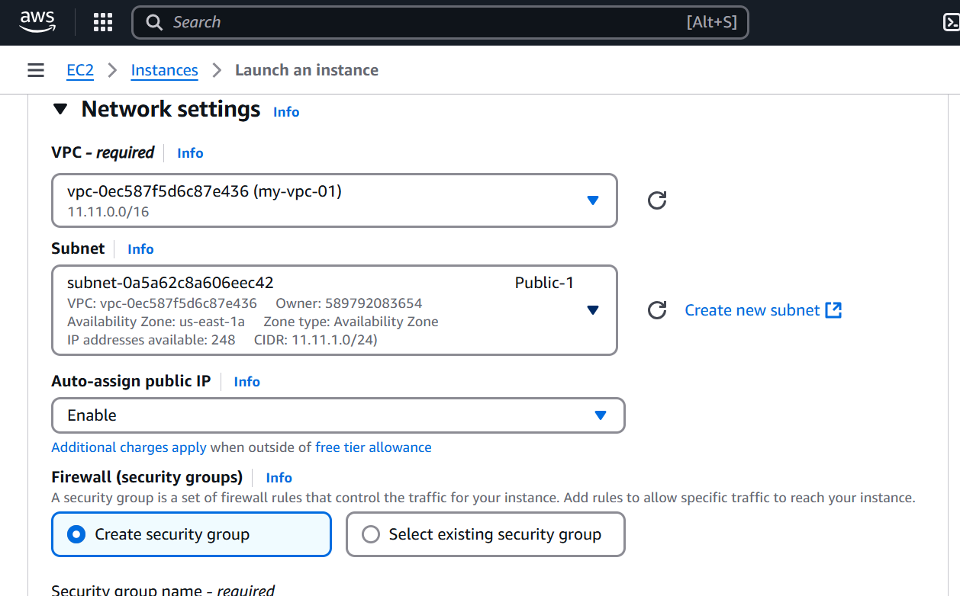

Click on launch instance

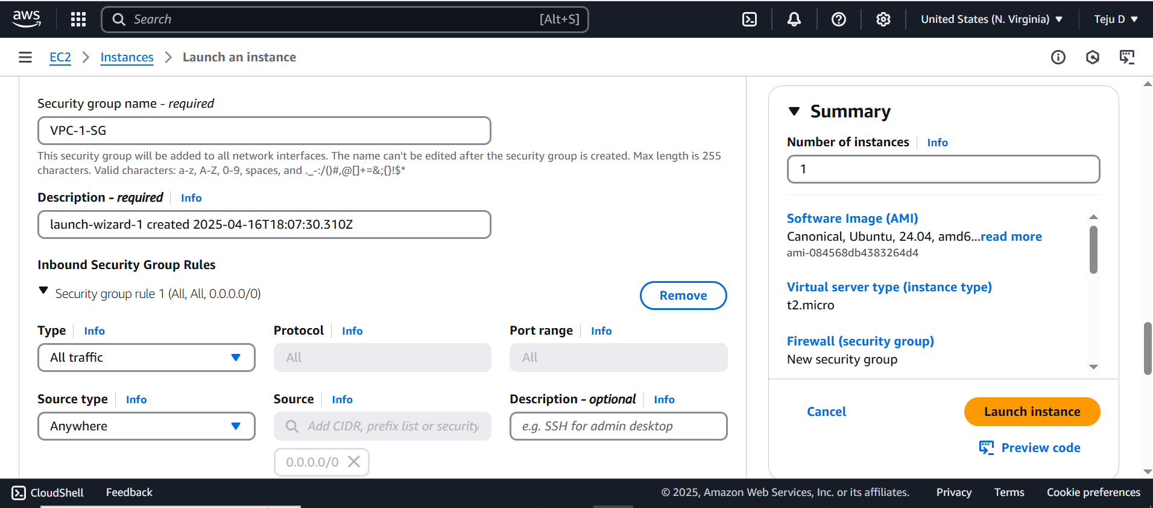

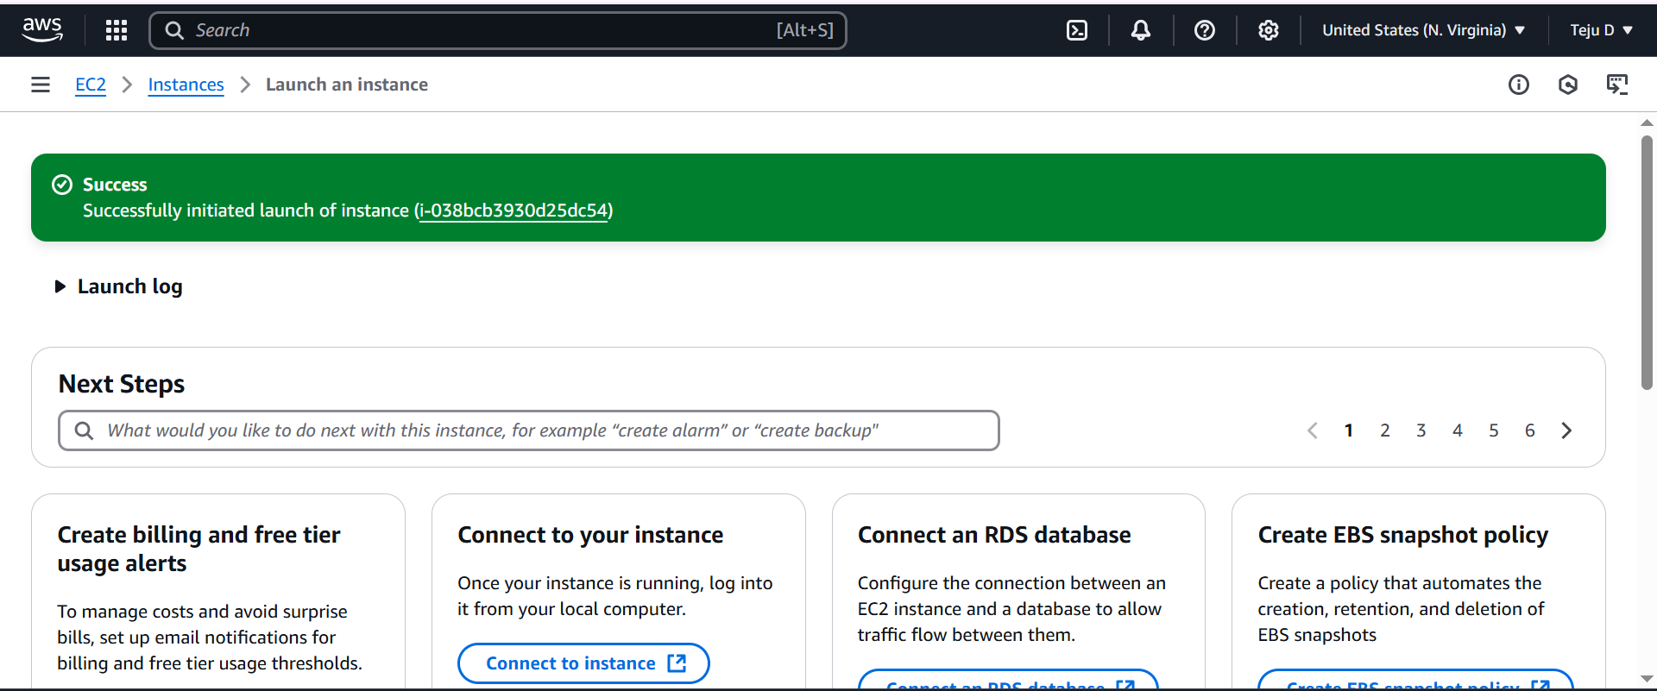

Launch 3 instances for Private-1, Private - 2 and Private 3 subnet - choose free tier AMI and instance type – choose existing keypair – choose existing security group

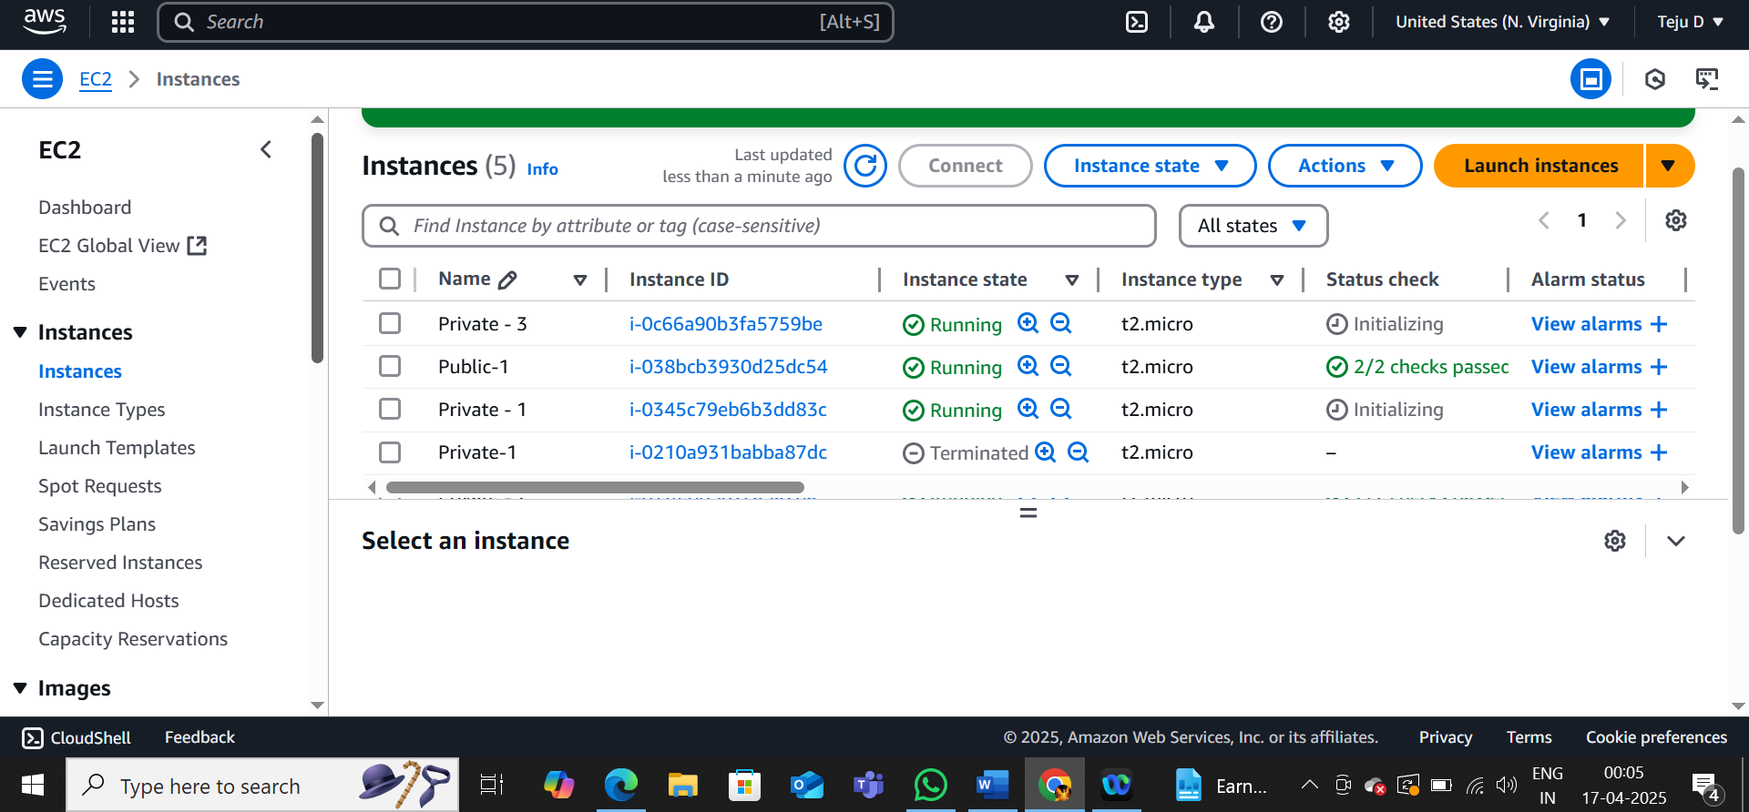

Connect to the Public-1 server directly and perform the below commands

* sudo apt-get update
* ping google.com
* Press Ctrl+C to stop ping

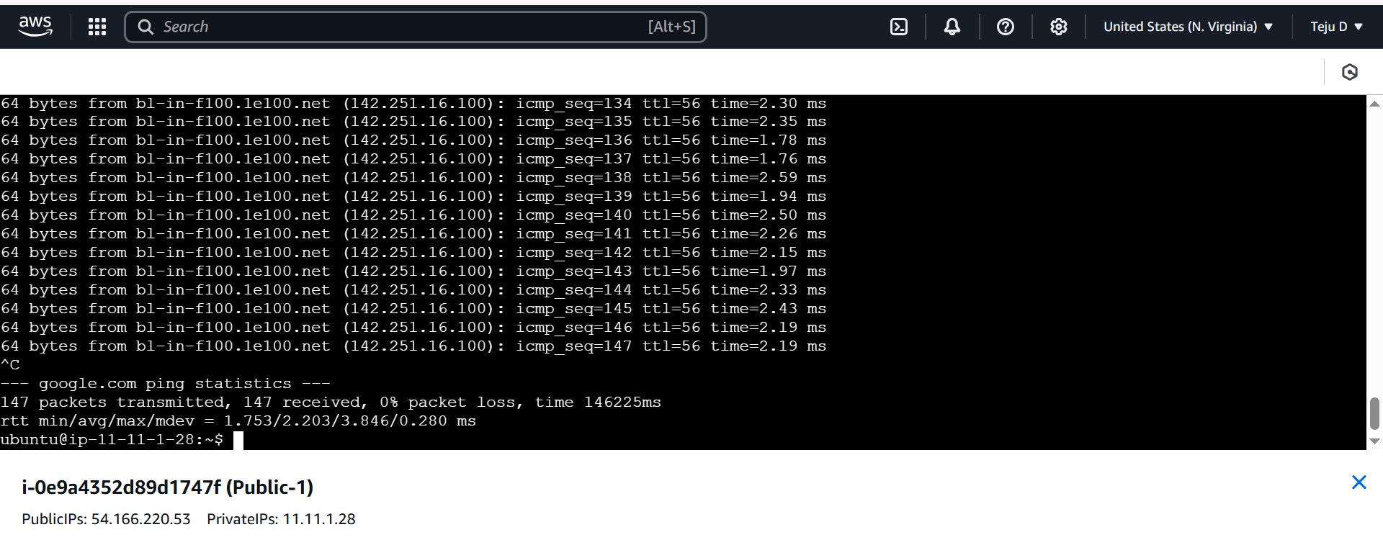

Connect Private-1 instance. You cannot connect this directly since there is no public IP. So use SSH to connect to the server.

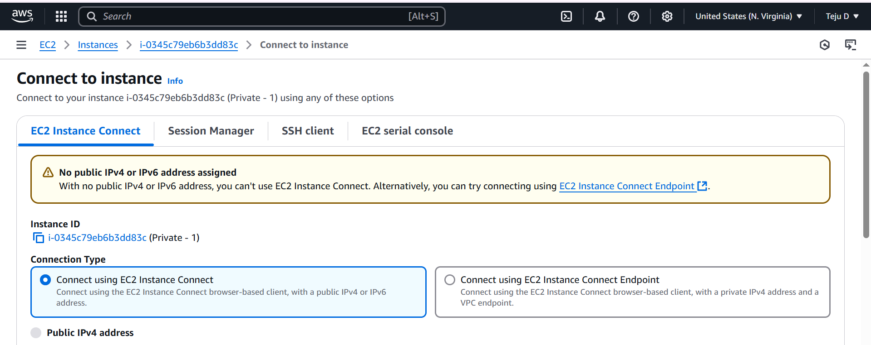

Go to SSH client – copy the key pair name

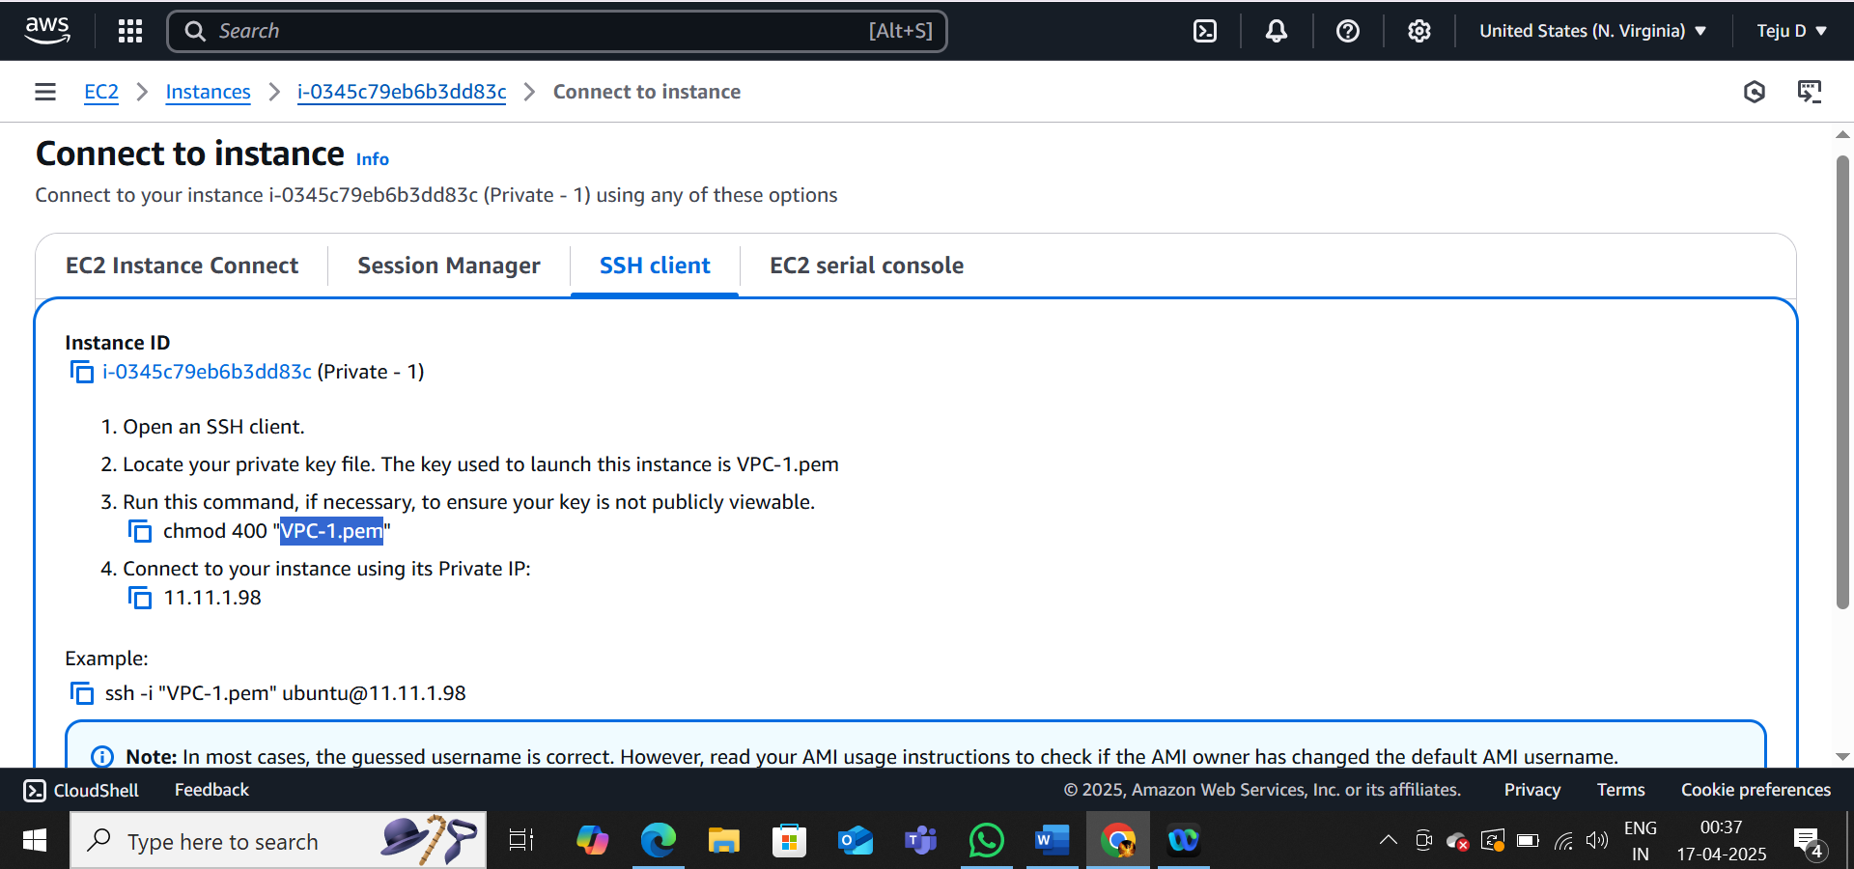

Use the public server machine, follow the below commands

Use the command – sudo nano VPC-1.pem

Paste the keypair content in the nano page

Press Ctrl+s and Ctrl+x to save and get back to the server

Perform the commands: sudo chmod 400 VPC-1.pem

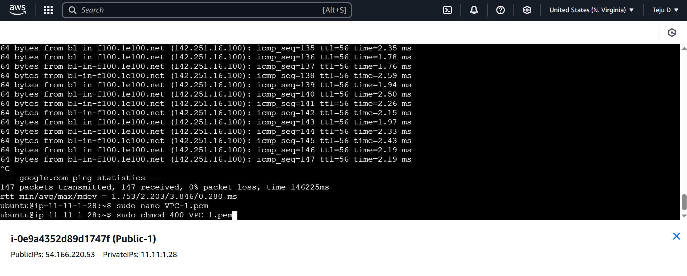

Copy the example and paste it in the server

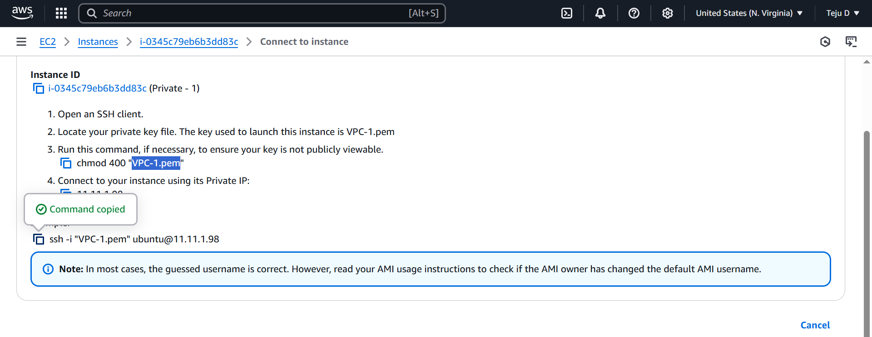

Perform the command: sudo ssh -i "VPC-1.pem" [ubuntu@11.11.1.98](mailto:ubuntu@11.11.1.98)

Press **Yes**

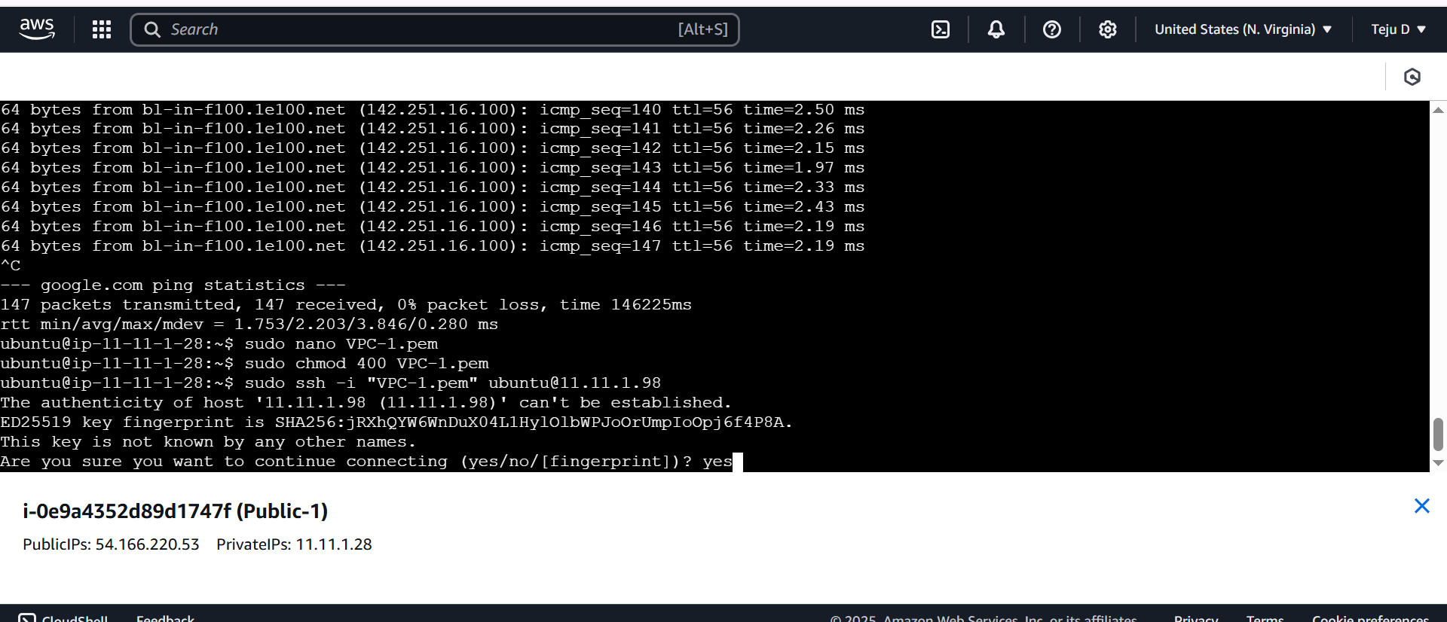

Use the below commands

* Sudo apt-get update
* ping google.com
* exit

use the exit command to close the private-1 connection

Now test the connection for Private-2 using the below commands

* Sudo ssh -i "VPC-1.pem" [ubuntu@11.11.3.28](mailto:ubuntu@11.11.3.28)
* And press **yes**
* Sudo apt-get update
* Ping google.com
* exit

Copay the paste the ssh command

